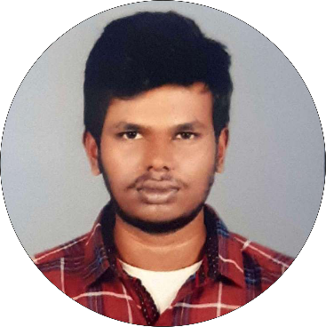

**Education**

**Master of Science in Computer Science (M.Sc cs)**

RVS College of Arts and Science -Coimbatore

* From 2021 to 2023
* Pursuing

**Bachelor of Science in Computer**

**Science (B.Sc cs)**

RVS College of Arts and Science - Coimbatore

* From 2018 to 2021
* 70%

**HSC**

Direct Appearance - Coimbatore

* From 2018
* 60%

**Phone:**

+91 8489902902

**Email:**

[thirugopi733@gmail.com](mailto:thirugopi733@gmail.com)

**LinkedIn:**

<https://tinyurl.com/bddyz298>

**GitHub:**

<https://tinyurl.com/39nrr99u>

**Website:**

<https://tinyurl.com/2dv9xhe4>

**Address:**

2/412 Thirumalai Nagar, Ganapathypalayam,

Tiruppur – 641 605.

**Contact**

**Professional Skills**

**Front-End:**

HTML, CSS

**Backend:**

Nodejs, JavaScript

**Database:**

MongoDB

**Graphic Design:**

Corel Draw Designer

**Hobbies**

Playing Volley ball

Travelling

Listening Music

**THIRUNAVUKARASAN A**

**Languages**

**English:**

R W S

**Tamil:**

R W S

**Declaration:**

I hereby declare that the information furnished above is true to the best of my knowledge.

THIRUNAVUKARASAN A

**Career Objective**

I seek challenging opportunities where I can fully use my skills for the success of the organization